Appendix 1- Derivations of payoff and expected cost of misbehaviour on a BDM auction trial

For a more formal proof of the incentive-compatibility of the BDM task, we present a proof, originally adapted from Milgrom & Weber, 1982 in Al-Mohammad & Schultz, 2019. Terms have been edited slightly to reflect their usage in this thesis, but the proof otherwise remains the same.

We assume that any participant has smooth, continuous, and differentiable utility function. An example is shown in figure 6, where the red lines shows the expected utility of hypothetical participants for bids increasing along the x axis. The black straight lines show the differentiation of this utility function with respect to bid at certain points along this curve.

We know that the expected utility a participant has is the expected utility of winning the auction multiplied by the probability of winning the auction, plus the expected utility of losing the auction multiplied by the chance of losing the auction.

$$U\left(\overline{P}\right)=p_{win}⋅U\left(\overline{P}|win\right) + (1 - p_{win})⋅U\left(\overline{P}|loss\right)$$

In the main text of Chapter 2, and in Appendix 3 we discuss the closed form solutions to this expected utility when participants make bids against one computer randomly drawing its bid from a uniform distribution. Here we consider a participant bidding in a ‘life-like’ auction where a participant bids against any number of other bidders with unknown utility functions of their own.

This participant places a bid, $B_{subject}$, which determines whether they win an auction against any number of other bids $B_{opps}$, where the maximum of these, ${\hat{B}}_{opps}$ determines the price paid in the event of the participant winning the auction. The probability of winning or losing any auction trial is therefore a cumulative distribution function of the opposing bids, $f$($B_{subject}$) bounded by the minimum possible bid, $B_{min}$, and the subjects bid.

$$U\left(\overline{P}\right)=\int_{B_{min}}^{B_{subject}}{U\left(\overline{P}|win\right)f({\hat{B}}_{opps})d{\hat{B}}_{opps}+ \int_{B_{subject}}^{B_{max}}{U\left(\overline{P}|loss\right)f({\hat{B}}_{opps})d{\hat{B}}_{opps}}}$$

As we are considering auctions as commonly understood in the marketplace (and not as carried out in economic/psychological/neuroscientific contexts), we assume that the utility $U\left(\overline{P}|loss\right)$ is zero; the participant neither wins, nor pays anything for an auctioned good.

$$U\left(\overline{P}\right)=\int_{B_{min}}^{B_{subject}}{U\left(\overline{P}|win\right)f({\hat{B}}_{opps})d{\hat{B}}_{opps}+ \int_{B_{subject}}^{B_{max}}{0 f({\hat{B}}_{opps})d{\hat{B}}_{opps}}}$$

$$U\left(\overline{P}\right)=\int_{B_{min}}^{B_{subject}}{U\left(\overline{P}|win\right)f({\hat{B}}_{opps})d{\hat{B}}_{opps}}$$

The expected utility of the payoff, given that the participant wins the auction is equal to the utility of the won good ($G$), minus the payment for the good

$$U\left(\overline{P}\right)=\int_{B_{min}}^{B_{subject}}{U\left(G - {\hat{B}}_{opps}\right)f({\hat{B}}_{opps})d{\hat{B}}_{opps}}$$

The maximum utility to a participant, $U\left(\overline{P}\right)$, occurs when the first derivative of their expected utility with respect to their own bid $B_{subject}$ is zero. At exactly this point, the change to their utility as they change their bid is zero. Moving their bid to either side of this point causes the change to utility with respect to the bid to become negative.

$$\frac{dU\left(\overline{P}\right)}{dB_{subject}}=U\left(G - B_{subject}\right)f(B_{subject}) = 0$$

It is clear that this equation is satisfied when the brackets of the utility function are equal to zero, that is, when the value of the good$G$ in units of the budget is equal to $B_{subject}$. In other words, this maxima is found when the utility of a good is exactly matched by the utility of the budget bid by a participant; a subject maximises utility by bidding exactly their utility for a good.

For a graphical representation of this proof, see figure 3 where the change in payoff value (in utils) is flat with respect to the bid, at the point where the bid is equal to the utility of the auctioned good (red circles).

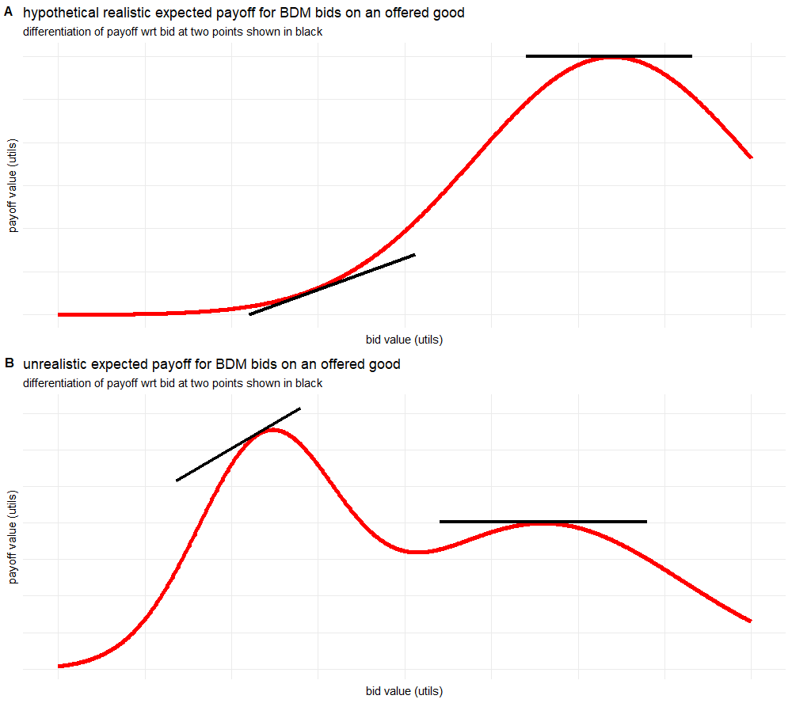
Figures 6a-b): Examples of smooth, continuous, differentiable utility functions for expected payoff vs. bid. In a) a realistic utility function for the simple BDM paradigm used in this thesis is shown. This is directly comparable to those found in figure 3, especially those for the uniform distribution. Differentiation of the curve is shown in black lines at two points, one at a maxima (the optimal bid as shown in the derivation in this appendix), and one which is not at an optimal bid. In b) we present a hypothetical utility curve for some more complicated paradigm (or indeed a participant who does not understand the paradigm presented). This is not a utility curve we would expect to encounter in the scope of this thesis, but is used to make the point that the proof above will still find local maxima or minima for a subjects utility function. Again, the derivative of the curve is shown at two points, including at one local maxima. Curves are for illustrative purposes and so are valueless across both axes.

This of course makes no difference to the proof, but is how the proof is formulated by Milgrom and Weber. In the BDM as discussed in the body of this thesis we assume there to be some utility just from receiving the endowment gifted to the participant at the start of each trial, but this utility should be ‘baked in’ to the participants expected payoff and so does not change the results, or implications, of the derivation here. It is actually probably untrue that the utility even of human’s buying and selling mineral rights (the example in Milgrom and Weber, 1982) is zero (see below).
This assumption is economically sound, but probably psychologically tenuous. Consider a child on Christmas Day who has spent the last six months expecting a specific gift and instead receives nothing.
Figure 6b) does in fact have a local minima at roughly the mid-point of the x-axis which contradicts this. A more stringent proof would state that this maxima is only a local maxima. For complicated utility functions that might arise (e.g.) as the BDM task is extended and extra round of bidding/payments/chance are incorporated this could become important. For the simple BDM paradigm in this thesis and in the lifelike auctions of Milgrom and Weber we assume a ‘simple’ utility curve with only one maxima as presented in figure 6a) and figure 3.

